CODE

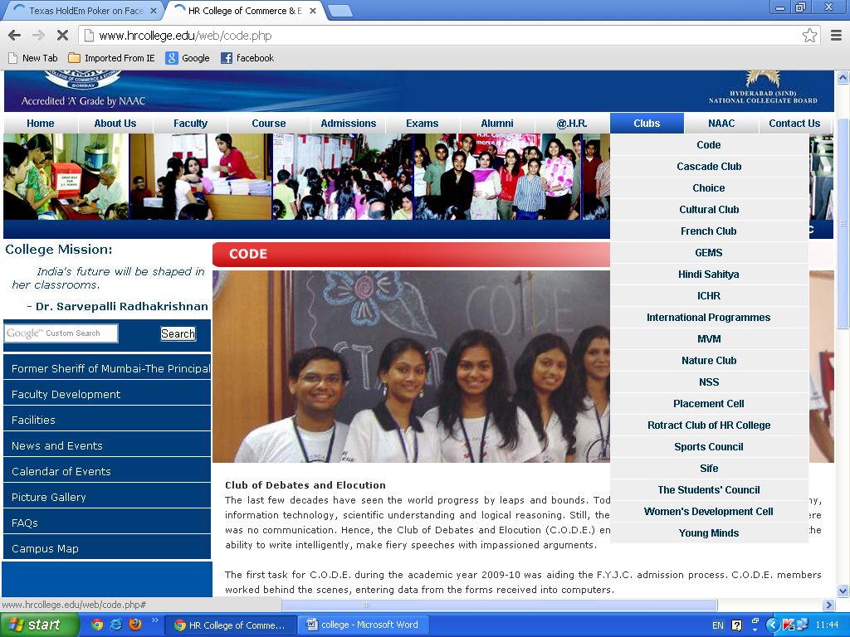

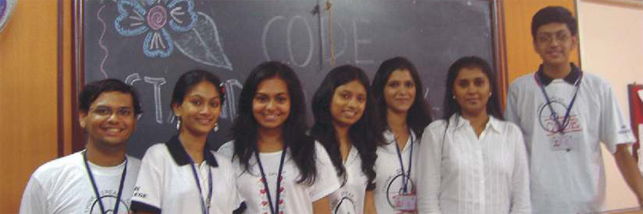

**Club of Debates and Elocution**  
The last few decades have seen the world progress by leaps and bounds. Today’s world is defined by a global economy, information technology, scientific understanding and logical reasoning. Still, there would be no semblance of order if there was no communication. Hence, the Club of Debates and Elocution (C.O.D.E.) endeavors to empower each member with the ability to write intelligently, make fiery speeches with impassioned arguments.  
  
The first task for C.O.D.E. during the academic year 2009-10 was aiding the F.Y.J.C. admission process. C.O.D.E. members worked behind the scenes, entering data from the forms received into computers.  
  
Next came C.O.D.E.’s flagship event-‘Stand Up, Speak Up!’ which is an impromptu speaking competition for the F.Y.J.C.s. On the maiden day of F.Y.J.C. lectures itself, the C.O.D.E. core committee conducted the elimination round in all eight divisions covering almost 90 contestants. After much deliberation, the committee released a list of 25 semi-finalists, who had been a cut above the rest.  
  
During the semi-final, each student was individually briefed on the way he/she could improve. Ultimately, 9 students made it to the final round of Stand Up, Speak Up! In the final round, every speech was an indigenous mix of philosophy, humour and detail. Many teachers and students graced the occasion with their presence. Krusha Sehjwani, Natasha Bana and Meherzeen Avasia were presented the 1st, 2nd & 3rd place awards respectively.  
  
H.R.’s very own inter-club fiesta, Talent Parade, saw C.O.D.E. play a dual role. Half the comperes of the show were C.O.D.E. members while the other members set the stage ablaze by putting up a scintillating dance performance dedicated to Michael Jackson. The theme of the dance ranged from current problems like terrorism to problems like racial discrimination. A sharp contrast of props, namely black hats and white gloves blended together to form a visual delight while the audience tapped their feet to the evergreen tune ‘Black or White.’  
  
The first inter-collegiate event of the year for C.O.D.E. was an English Elocution Competition held by the ‘Gandhi Smarak Nidhi’ at the historic Mani Bhavan. H.R. was represented by Nihal Daswani, Chantelle Duarte Monteiro and Meherzeen Avasia. Over 30 participants spoke on various topics related to Gandhiji’s role in the freedom struggle. Nihal Daswani was awarded the 1st Prize.  
  
C.O.D.E., on behalf of H.R., participated in an essay writing competition organized by the Swiss Embassy. The aim of the competition was to promote Indo- Swiss ties with the theme being ‘Tourism in Switzerland’. C.O.D.E. held a tryout in college, short listed the best essays, and forwarded four English and five Hindi entries. An S.Y.J.C. student, Richa Mohnani won the 3rd prize.  
  
St. Andrews College, Bandra, held an inter-college elocution competition for Junior College students. Nihal Daswani represented H.R. and spoke on the topic ‘Men Smart Women Smarter’ for which he was awarded the ‘Best Speaker’ prize.  
  
The Annual Prize Distribution for the Junior College was held in December and was hosted by Nihal Daswani, Lekha Bapna, Chintan Shah and Natasha Bana,all members of C.O.D.E.  
  
At the Annual Sports Day, the F.Y.J.C. C.O.D.E. members took charge of the refreshment stand, ensuring that all the dignitaries and participants were kept hydrated throughout the meet.   
  
In this manner, C.O.D.E. has succeeded in producing a generation of confident youth, well-read, well-spoken and wellopined; a generation that is bold enough to know that ‘Speech is Silver’ and yet humble enough to learn that sometimes ‘Silence is Golden.’

CASCADE CLUB

|  |  |
| --- | --- |
| **CASCADE CLUB** Enriching students’ potential, shaping theirpersonality, nurturing their talents and giving them the platform they deserve is what the CASCADE CLUB (co-curricular club) is all about. Cascade club is a perfect combination of HARDWORK, EFFICIENT MANAGEMENT and a lot of FUN which leads to SUCCESS in every event undertaken. It believes in its slogan “EXCEL IN ACADEMICS, EXCEL IN ACTIVITIES”. The CASCADE core team had decided not to refuse membership to anyone as everyone | http://www.hrcollege.edu/web/images/Voyager2009-2010/CASCADE%20CLUB.jpg |
| has some unique talent and we help to bring it out. The following events were conducted during the academic year 2009-10.  The Junior College members were in action much before the academic year had begun, they were helping the students’ council with admission work. The admission process can be grilling for any new comer and the students helped the new entrants to make the transition as easy as possible.  **EVENTS :** Mehendi Designing Competition- August 6, 2009. Card Making Competition - August 11, 2009. CASCADE also celebrates the most awaited week of H.R i.e the H.Rite Week H.Rite SPECIAL WEEK CELEBRATION - December 1 - 5, 2009. Denim Day : December 1 Twins Day : December 2 Black n White Day : December 3 Traditional day : December 4 Indo-Western Day : December 5 CASCADE members were in charge of the reception and hospitality for the following programmes:   * Welcoming Freshers and active participation in admission process. * Participation in “Awareness on Terrorism” programme organised by Mumbai Police, NCPA. * Organising an entertainment programmes for students of King’s College (UK) and NYU Stern(USA). * Participation in “Missing for a Mission” - a programme for providing solar lanterns to villagers.   **Core Committee :** **Profs.-in-charge :-** Mrs. Rekha Verma, Ms. Dipti Acharya **SYJC Members :-** Ankita Bari, Khanjan Gohil **FYJC Members :-** Disha Dedhia, Khushboo Shah, Deepika Sachdev, Shreya Shah, Pallavi Maheshwari, Yuga Deodhar, Yogini Vaidya, Mokshesh Shah, Raj Vyas | |

C.H.O.I.C.E

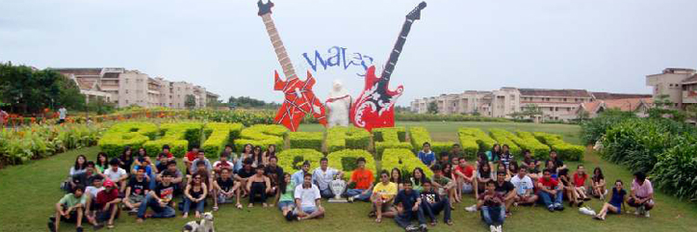

The Council for Handling and Organizing Inter-Collegiate Events (C.H.O.I.C.E.) is a prominent club of H.R. College. It is responsible for identifying potential talent in students & representing the college at all Inter collegiate events.  
  
For the statistically minded, H.R. is the only college in Mumbai to have won all major festivals - Malhar, Kaleidoscope, Brouhaha, Kshitij & Kiran in addition to having placed in the top 3 at each and every festival over the last eight years.  
  
C.H.O.I.C.E. sailed into the academic year 2009-2010 with Professor-in-charge Mr. Amit Nandu, President Karan Pandya and Vice-Presidents Danesh Irani & Anushka Shetty at the helm. Assisting them was a diverse crew of directors and volunteers, enthused at the prospect of winning accolades for the college.  
  
The first event on C.H.O.I.C.E.'s platter was to be H.R. Fest - an intra-collegiate festival.  
  
However, due to the dual problems of the delayed F.Y.J.C. admissions as well as the subsequent swine flu pandemic, H.R. Fest was cancelled despite all the preparations having been made.  
  
In August, after two months of tiring days and sleepless nights, the C.H.O.I.C.E. contingent, led by Karan Pandya, stormed into Malhar at St. Xavier's College. By winning numerous flagship events, H.R. finished 3rd overall.  
  
In August, after two months of tiring days and sleepless nights, the C.H.O.I.C.E. contingent, led by Karan Pandya, stormed into Malhar at St. Xavier's College. By winning numerous flagship events, H.R.finished 3rd overall. The first fortnight of September brought with it a new Vice-President, Dhruv Khopkar.  
  
To commemorate H.R. College's Golden Jubilee, a grand event was held at the Trident on the 19th September, 2009. Here, C.H.O.I.C.E. organized and performed a prayer dance dedicated to Lord Ganesha and a mega-parade to launch the new H.R. Song.   
  
In the very same month, C.H.O.I.C.E. participated in K.C. College's fest Kiran, with Sumit Shah as Contingent Leader. Everyone gave it their best shot, ensuring H.R. a 2nd place.   
  
Making an entry into C.H.O.I.C.E.'s calendar this year, was an outstation festival - Waves. The 70 member contingent, led by Nihal Daswani traveled all way to BITS Pilani's Goa Campus in November, where they stayed for five days. Despite being away from 'homeground' the contingent managed to win the hearts of hosts and judges alike, sweeping the Dance, Music & Literary Arts events in addition to the coveted Overall Trophy. By doing so, H.R. College, won its First Outstation Trophy, defeating talent from all over the nation.   
  
On returning from Goa, C.H.O.I.C.E. had barely a week before the next major festival - Kaleidoscope, held at the sprawling campus of Sophia College. With Danesh Irani as Contingent Leader, and a grand victory behind them, C.H.O.I.C.E. entered Kaleidoscope with all guns blazing. After a week of non-stop, back-to back events, H.R. was awarded the runner-up trophy.  
  
December proved to be twice as nice with C.H.O.I.C.E. winning both Kshitij and Brouhaha, which took place at Mithibai College and Sydenham College respectively.   
  
Under the able leadership of Dhruv Khopkar, H.R. won Kshitij for the second year in a row by over 2000 points, even though the performers and organizers had their terminal examinations in the week preceding the festival. In addition to winning the Overall trophy, H.R. also swept the Literary Arts and Performing Arts trophies.   
  
For the eighth consecutive year, the Brouhaha trophy came home to H.R., this time with Jehan Madan as Contingent Leader. Once again, the Literary Arts, Performing Arts, Fine Arts, Sports & Gaming events were swept by C.H.O.I.C.E., a fine end to the calendar year!   
  
In January 2010, the Diamond Jubilee of the Hyderabad Sind National Collegiate Board was celebrated at the NCPA, where C.H.O.I.C.E. members performed a classical dance dedicated to Lord Ganesha.   
  
The following month, H.R. College embarked on an ambitious project- Project Chirag, an attempt to provide solar powered lamps to all the houses of a village on the outskirts of Mumbai. The cost of the project was estimated at Rs.3,650/- per house which was to be attained by way of sponsorship. C.H.O.I.C.E. members enthusiastically helped in locating sponsors and raising funds worth a whopping Rs.2,00,000/- for approximately half the houses in the village.   
  
On the whole, glancing at 2009 - 2010 through a Kaleidoscope, C.H.O.I.C.E. has ensured a perennial Malhar at H.R., bringing a Kiran of knowledge and experience in every member's life. While making a Brouhaha in the college and yet reaching the highest Kshitij in the inter-college arena, it cannot be denied that C.H.O.I.C.E. is making Waves everywhere.   
  
**INTER-COLLEGIATE TROPHIES WON BY C.H.O.I.C.E. (H.R. COLLEGE)**  
  
**Waves - BITS Pilani, Goa**  
H.R.'s first Outstation Trophy, 1st place overall, sweeping the Performing Arts & the Literary Arts departments  
  
**Kshitij - Mithibai College**  
Overall trophy along with Performing Arts & Literary Arts trophies for the second year in a row.  
  
Brouhaha - Sydenham College  
Overall trophy along with Performing Arts, Literary Arts, Fine Arts, Gaming & Sports departments for the 8th year in a row  
  
**Kaleidoscope - Sophia College:** 2nd place  
**Kiran - K.C. College :** 2nd place  
**Malhar - St. Xavier's College :** 3rd place  
  
**The C.H.O.I.C.E. Board**  
**Professor-in-charge :** Mr. Amit Nandu  
**President :** Karan Pandya  
**Vice Presidents :** Danesh Irani, Anushka Shetty, Dhruv Khopkar  
**Directors :** Sumil Shah, Rohan Sanjana, Sumit Shah, Saba Bagdadi, Prabtej Gadh, Priyanka Sawhney, Isha Amin, Nihal Daswani, Jehan Madan, Aastha Samtani.

FRENCH CLUB

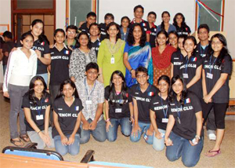

|  |  |
| --- | --- |
| |  | | --- | | **FRENCH CLUB** The French Club of H.R. College of Commerce and Economics celebrated the French National Day on July 18,2009. It started off with a welcome speech in English given by Darshan Shah, President of the French Club and a speech in French by Prof. Melisa Alva. It was followed by the French National Anthem - La Marseillaise, sung by Utkarsh, a student of SYJC.  The audience was then shown a PowerPoint presentation as to why July 14 is celebrated as the French National Day and how the celebrations take place in France. Principal Dr. Indu Shahani, Prof. Sharma and our Vice-Principal, Prof. Anila Pillai addressed those present. | |
| Students presented a French dance which was followed by a presentation of the activities of the French Club and the Investiture Ceremony. An interactive session between the Principal, teachers and students followed. The programme concluded with a vote of thanks given by Prof. Melisa Alva.  The French Fiesta was organized on November 27, 2009. it proved to be an overwhelming experience with various competitions like calligraphy, fashion design, sketching, essay writing and poetry competition in French. A rink football tournament took place simultaneously.  The event was graced by Prof. V.N.Sharma and the Vice-Principals of the Junior College Mrs. Anila Pillai and Mrs. Dipika Bhatia. The event had loads of fun along with a touch of French culture. During the programme, students sang French songs and danced to French numbers. The winners of the various competitions were felicitated. It came to an end with the singing of the French National Anthem by Utkarsh, an SYJC student.  **FRENCH CLUB - Core Committee** **Prof-in-Charge :** Milita Ganguly, Melisa Alva, Vasudha Arya,  **SYJC members :** Darshan Shah, Meenakshi Maheshwari, Mamta Mamtani, Priya Malloo, Utkarsh Shah,  **FYJC members :** Narotam Madhyam, Varun Panjwani, Pawan Madani, Medha Avasia, Akshya Alamchandani, Depish Shah, Ritika Punwani. |

GENERAL EVENT MANAGEMENT

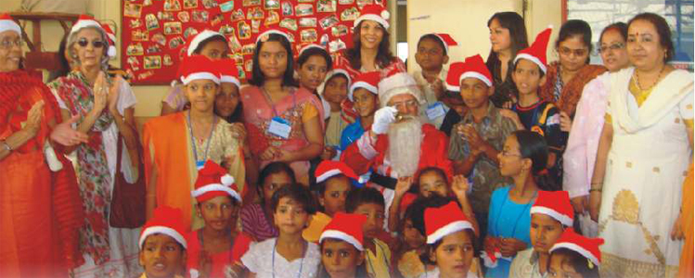

**Installation Ceremony :** The Installation Ceremony for GEMS was held on 10th August, 2009 in the Conference Room. The newly elected President Karishma Rajani introduced her new set of Directors for G.E.M.S. 2009 - 2010 to the members. Dr. Indu Shahani, Principal of H.R. College graced the occasion and launched the official club T-Shirt along with senior college Vice Principal Mrs. Rekha Bahadur kicking off yet another eventful year of G.E.M.S. activities.  
  
**Scavenger Hunt :** On 12th July, 2009, G.E.M.S. organized a Scavenger Hunt for its members. In this event, the participants were given a list of items which they had to search for in and around Churchgate within a stipulated period of time. Like last year, Scavenger Hunt was yet again, just perfect to start off another year for The General Event Management Society.  
  
**Bowling :** The first outing with the members was in the month of June to Co’s In Phoenix Mills. We had a good competitive event followed by a brunch.  
  
**Gems Chase :** An adventurous event based on the lines of the hit reality show “The Amazing Race” had the club members roaming all over south Mumbai solving clues and doing various tasks all throughout the day. In the bargain they learnt how to work as a team and to manage money in a productive way. Besides having loads of fun the members bonded with each other.  
  
**Gemmy's :** It was an award night held during the outstation trip where a number of members were appreciated for their hard work and duly felicitated.  
  
**Bazaar '09 :** Since the past 3 years, the General Event Management Society, has been organizing Bazaar successfully. This year Bazaar ’09 was bigger and better as it transformed from a business management exercise to a business management competition. The event was graced by the presence of Vice Principal Mrs.Rekha Bahadur. The event was an overall success involving a lot of fun and games at the same time giving the participants a platform to showcase their entrepreneurship qualities.  
  
**Social Responsibility Project :** The members of G.E.M.S participated in the cancer awareness week organized by V CARE FOUNDATION as a part of the social responsibility project. Here the members took part in various activities to create awareness about this disease.  
  
**Christmas Party :** On the 24th December, 2009, with social responsibility as the motto, G.E.M.S. invited the kids of an orphanage called ‘Arzoo’ to spend time with us and enjoy the festive season with various activities.  
  
**Achievers' Day :** THE ACHIEVERS' DAY was organised on the 23rd December, 2009. All deserving students were recognized for the hard work put in throughout the year. The students were awarded prizes and certificates for excelling in academics, extra-curriculars, attendance and felicitated by the Principal of the college, Dr. Indu Shahani.

CONTACT US

address

**H. R. COLLEGE OF COMMERCE & ECONOMICS**

|  |  |
| --- | --- |
| http://www.hrcollege.edu/web/images/trans.gif | http://www.hrcollege.edu/web/images/trans.gif  123, Dinshaw Wachha Road, Churchgate, Mumbai 400 020 India  Tel:: +91 22 22876115 / 22042195 Fax: +91 22 22810758  Email: info@hrcollege.edu Website: www.hrcollege.edu |

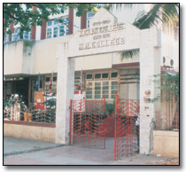

CAMPUS MAP

